1. **"Write aprogram to insert numeric year’s data into movies list to get an output asgiven below. movies = [""The Holy Grail"", The Life ofBrain"", ""The Meaning of Life""] years =[1975, 1979, 1983] # Output: [""The Holy Grail"" 1975,""The Life of Brain"", 1979, ""The Meaning ofLife"", 1983]"**

*#Assigning the movie names to the movies list and years to the year list*movies=[**"The Holy Grail"**,**"The Life of Brain"**,**"The Meaning ofLife"**]  
year=[1975,1979,1983]  
*#Using lambda function to map both the lists*lst3=list(map(**lambda** x,y:(x,y),movies,year))  
print(lst3)

OUTPUT:

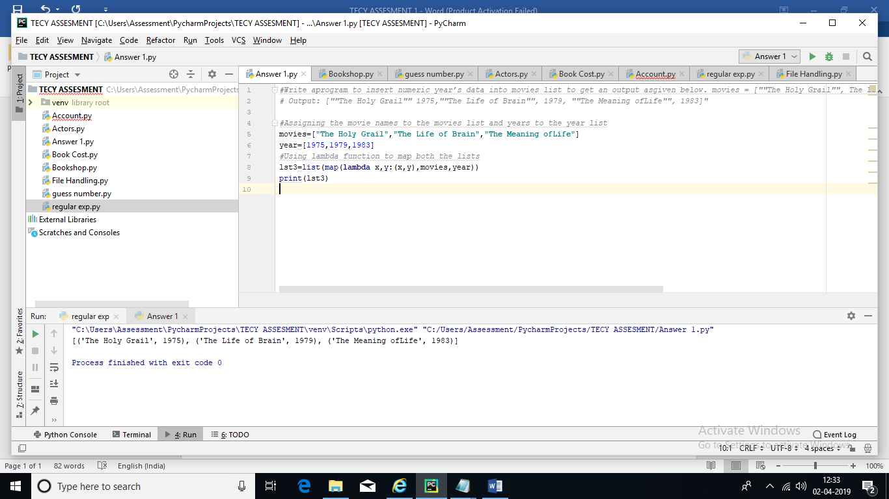

2. Suppose thecover price of a book is Rs.650/- but book store get a 40% discount. Shippingcost Rs.30/- and Rs.15/- for additional copies.

Write a program to calculatethe total wholesale cost for 25 copies?

*#Assigning the Coverprice, Discount,shipping cost and Additional copies cost to variables*Coverprice=650  
*#Discount of 40%is calculated*Discount_Bookstore=(650*40/100)  
Shippingcost=30  
Additionalcopies=15  
*#Calculating the total Bookprice*Bookprice=(Coverprice+Shippingcost)-(Discount_Bookstore)  
*#calculating the wholesale price*Totalprice=Bookprice*25  
print(**"The book price is:"**, Bookprice)  
print(**"The total price is:"**, Totalprice)

**OUTPUT:**

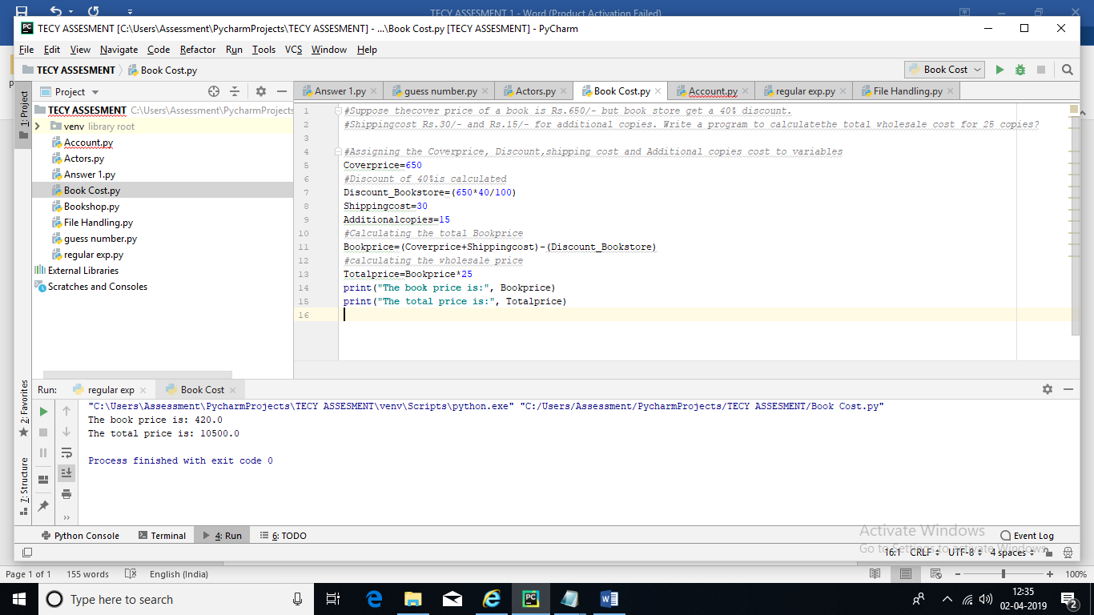

3. "Write aprogram to make a ‘Guess the Number’ game.

In this game the computer willthink of a Random number from 1 to 10, and ask you to guess the number.

Youwill get six guesses, But the computer tell you if your guess is too high ortoo low. If you guess the number within Five tries, you win. Output: Hello!Enter your name: Sharan Well Sharan, I am thinking of a number between 1 and10. Take a guess: 10 Your guess is too high Take a guess: 3 Your guess is toolow. 5 Good job, you guessed my number!

Note: Include exception handlingwherever applicable"

PROGRAM:

*#Importing random to call random numbers***import** random  
**try**:  
*#Using forloop for getting the iteration for range of numbers* **for** i **in** range(1, 7):  
 number = random.randint(1,10)  
 Guess_num = 5  
 number=input(**"Hello!Enter your name:"**)  
 print(**"I am thinking of a number between 1 and 10"**)  
 Guess=int(input(**"Guess a number:"**))  
  
 **break***#Using if condition to check the conditions given* **if** (Guess==10):  
 print(**"Your guess is too high "**)  
 **elif** (Guess==3):  
 print(**"Your guess is too low"**)  
 **elif** (Guess==5):  
 print(**"Good job! you guessed my number"**)  
 **elif** (Guess==0):  
 **raise** ValueError  
  
  
**except** ValueError:  
 print(**"Invalid Entry"**)

**OUTPUT:**

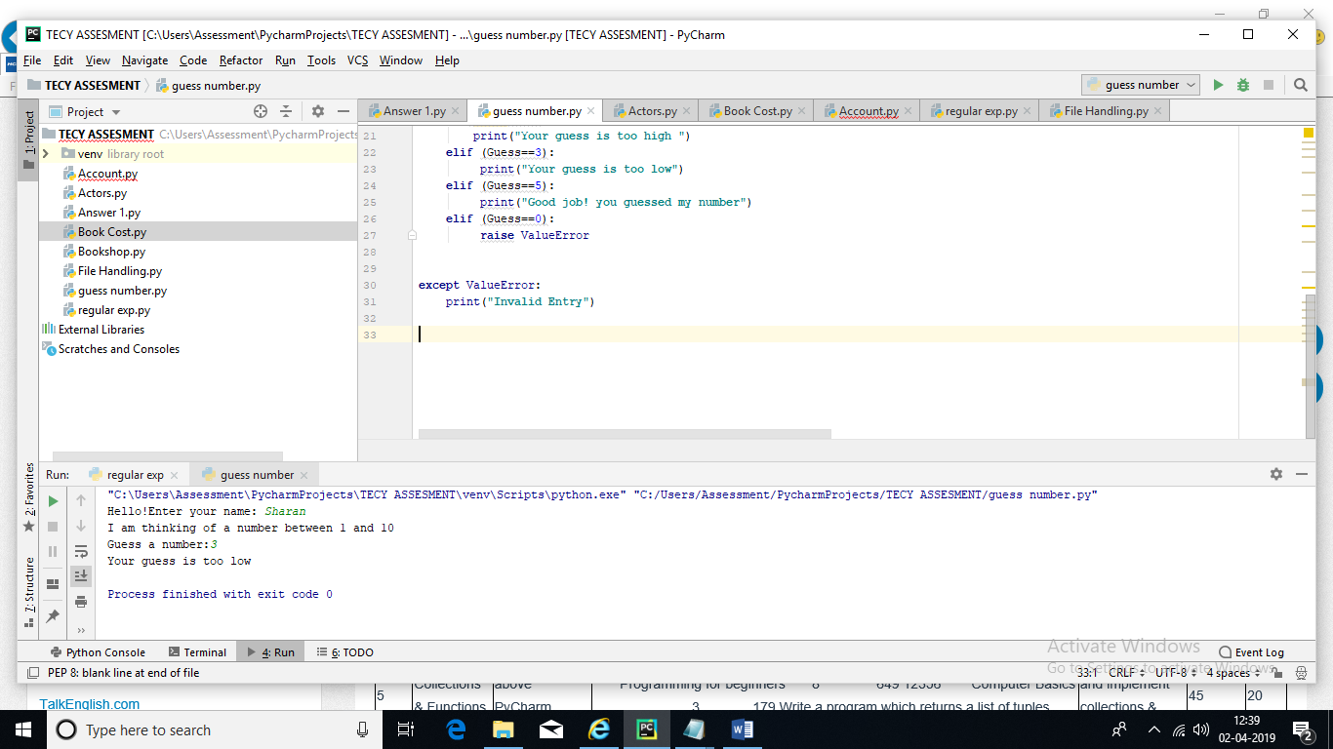

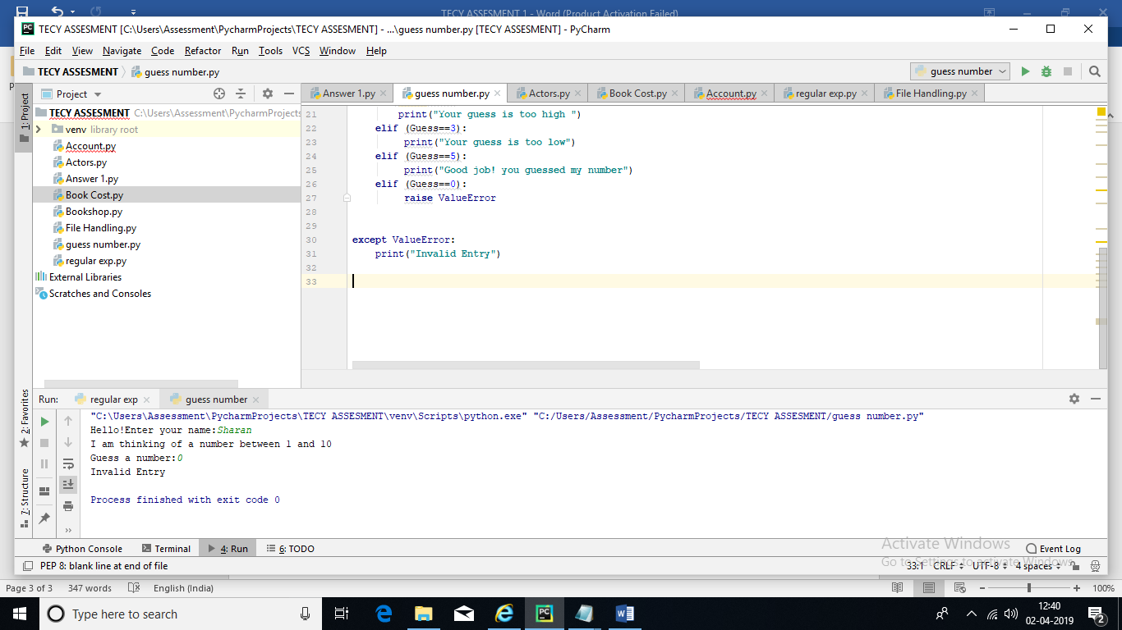

4. "Create amodule ‘actors’ that defines a list ‘cast’ with list of actor names givenbelow and that provides a function to display actors names. Write a programthat imports newly created module ‘actors’ and display the contents of thelist on the console.

Use the following list data Tom Cruise, Will Smith,Dwayne Johnson, Jackie Chan, Arnold Schwarzenegger"

PROGRAM:

*#DEFINING THE FUNCTION ACTOR***def** actors():  
 cast=[**"Tom Cruise, Will Smith,Dwayne Johnson, Jackie Chan, Arnold Schwarzenegger"**]  
*#CHECKING FOR THE ELEMENTS IN THE LIST* **for** elements **in** cast:  
 print(cast)  
*#CALLING THE FUNCTION*actors()

OUTPUT:

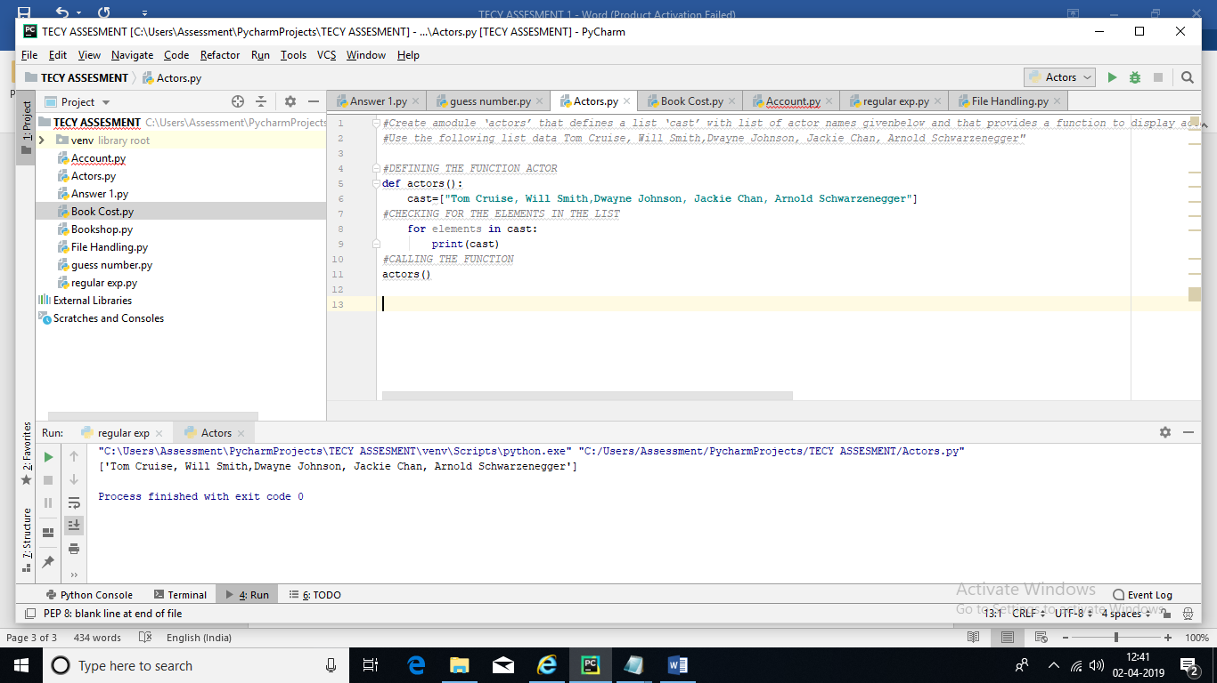

5. "Imaginean accounting routine used in a book shop. It works on a list with sub list,which look like this Order No Book Title Quantity Price Per Item 12354 Computer Programming 5 449 12355 Programming for beginners 8 649 12356 Computer Basics 3 179 Write a program which returns a list of tuples, each tupleconsists of ‘Book title’ and ‘Order total’ use lambda and map function

Output: [(<title>, <order-total>), (<title>,<order-total>), (<title>, <order-total>)] Note: Includeexception handling wherever applicable"

PROGRAM:

*#Assigning separate list which contains values of order number, BookTitle, Quantity and Price*Order_no=[12354,12355,12356]  
Book_Title=[**"Computer programmming"**,**"Programming for Beginners"**,**"Computer Basics"**]  
Quantity=[5,8,3]  
Price=[449,649,179]  
*#Using lambda function to map both the lists*tup1=list(map(**lambda** x,y:(x,y),Book_Title,Order_no))  
print(tup1)

**OUTPUT:**

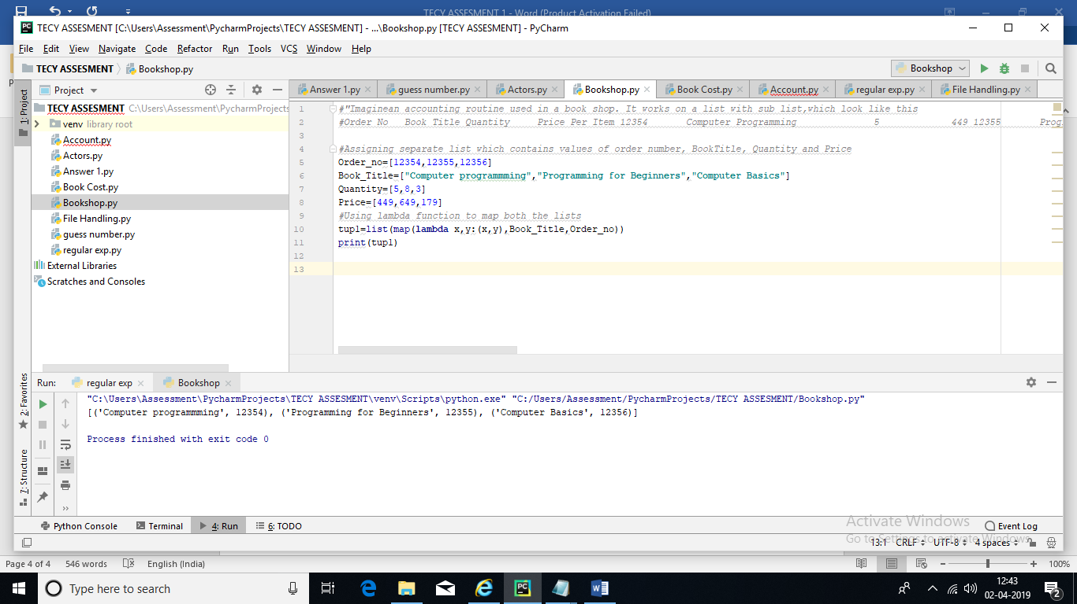

6. "Create aclass ‘Account’ with a constructor that accepts ‘customer name’ and balance.Default balance amount should be Rs.1000/-. Create two methods one fordeposit and another for withdraw. Allowed deposits/Withdraw should bemultiples of 100’s. Customer should maintain minimum balance of Rs.500/- andmaximum allowed deposit should be Rs.10000/-.

Create an object of an Accountclass and verify both methods Note: Include exception handling whereverapplicable"

PROGRAM:

*#Creating a class ‘Account’ with a constructor that contains‘customer name’ and balance***class** account:  
 **def** __init__(self,name,balance):  
 self.name=name  
 self.balance=balance  
*#Declaring default balance* default_bal=1000  
*#declaring minimum balance* min_bal=500  
*#Creating methods for deposit* **def** deposit(self,deposit):  
 **try**:  
 **if** deposit>100:  
 print(**"You can proceed"**)  
 **elif** (deposit>1000):  
 print(**"Exceeded maximum allowed deposit"**)  
*#Creating methods for withdraw* **def** withdraw(self,withdraw):  
 **if** deposit > 100:  
 print(**"You can proceed"**)  
 **elif**:  
 print(**"Withdraw should be multiples of 100"**)  
 **else**:  
 **raise** exception

OUTPUT:

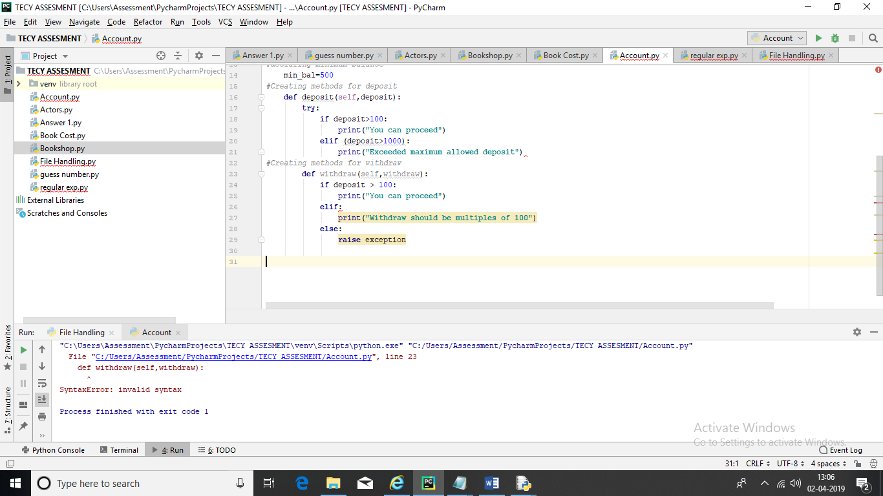

7. Write a regularexpression pattern to find ISD code from the mobile number given below '91-9962512345' and 919962512345.

*#Importing regular expression***import** re  
Assigning the phone numbers  
phone_number1=**'91-9962512345'**phone_number2=**'919962512345'**pattern=**'r'**,**'(2)(0-9)'***#Using regex findall function to find the required output*output1=re.findall(**'91'**,phone_number1)  
output2=re.findall(**'91'**,phone_number2)  
print(**"The isd code for first phone number is:"**,output1)  
print(**"The isd code for 2nd phone number is:"**,output2)

**OUTPUT:**

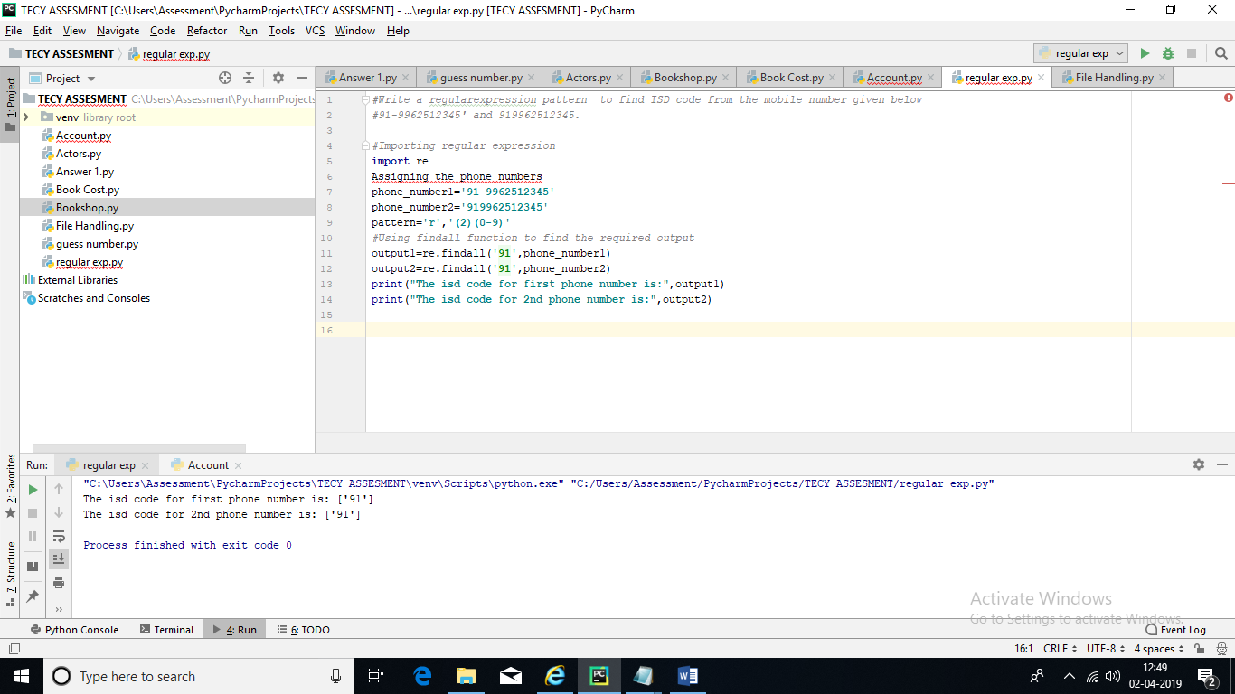

8. "Copycontents of one file to another file using for loop Note: Include exceptionhandling for all programs related to File operations"

PROGRAM:

file1=**with**(open(**"C:\\Users\\Assessment\\Desktop\\tecy new.py”,’r’)**)**as** file:  
 a=file.readline()  
 print(a)  
 file1.close()  
file2=**with**(open(**"C:\\Users\\Assessment\\Desktop\\tecy new1.py”,’w’**))**as** file:  
 **for** i **in** a:  
 file2.write(i)  
 file2.close()

**OUTPUT:**

